**SCENARIOS:-**

**Creating child cases in Pega can be beneficial in various scenarios. Here are a few examples:**

1. Insurance Claims: In an insurance claims process, a parent case for a car accident can create child cases for vehicle damage, bodily injury, and property damage. Each child case represents a specific aspect of the claim that needs to be processed separately.

2. Customer Service: In a customer service application, a parent case for a complaint can create child cases for different types of resolutions such as refund, replacement, or compensation. Each child case represents a specific action that needs to be taken to address the customer's complaint.

3. Project Management: In a project management application, a parent case for a project can create child cases for different tasks or milestones that need to be completed. Each child case represents a specific deliverable or activity within the project.

4. Healthcare: In a healthcare application, a parent case for a patient can create child cases for different medical procedures, appointments, or tests. Each child case represents a specific healthcare service that needs to be provided to the patient.

These are just a few examples of scenarios where creating child cases in Pega can help in organizing and managing complex business processes. By breaking down the work into smaller, manageable units, child cases enable efficient collaboration, parallel processing, and better tracking of progress.

**Here are some scenarios where child cases can be created in Pega without using a list:**

1. Incident Management: In an incident management application, a parent case for a security breach can create child cases for different aspects of the incident response, such as forensic analysis, communication with stakeholders, and remediation actions. Each child case represents a specific task or activity related to the incident.

2. Compliance Management: In a compliance management application, a parent case for a regulatory audit can create child cases for different compliance requirements, such as data privacy, financial reporting, or internal controls. Each child case represents a specific compliance task that needs to be addressed.

3. Employee Onboarding: In an employee onboarding application, a parent case for a new hire can create child cases for different onboarding activities, such as IT setup, training, and documentation. Each child case represents a specific step in the onboarding process.

4. Service Request Management: In a service request application, a parent case for a customer request can create child cases for different service tasks, such as scheduling an appointment, dispatching a technician, or processing a payment. Each child case represents a specific service action required to fulfill the customer's request.

**Here are some detailed scenarios where multiple child cases can be created using a list in Pega:**

1. Insurance Claims: In the insurance industry, when processing a claim, there can be multiple types of coverage involved. For example, in a car accident insurance claim, there may be separate child cases for vehicle damage, bodily injury, and property damage. Each of these child cases can be created using a list in Pega, allowing for parallel processing and efficient resolution of the overall claim.

2. Travel Applications: When customers make travel reservations, there can be multiple components involved, such as flights, hotels, and car rentals. Each of these components can be treated as a separate child case in Pega. By creating a list of child cases, the travel application can handle each reservation independently, allowing for flexibility and easy management of the overall travel process.

3. Customer Service Processes: In customer service scenarios, there can be various feedback or resolution steps involved. For example, when handling a complaint, there might be multiple child cases created for different stages of resolution, such as investigation, resolution, and follow-up. By using a list of child cases, the customer service process can efficiently track and manage each step, ensuring a comprehensive and satisfactory resolution for the customer.

4. In a healthcare application, a parent case for a patient can create child cases for different medical procedures, appointments, or tests. These are just a few examples of scenarios where multiple child cases can be created using the list feature in Pega. The flexibility of creating and managing child cases allows for efficient and structured processing of complex business processes

**CONFIGURATIONS:**

**1.Creating a Child Case From App Studio:-**

1. Create a Case Type

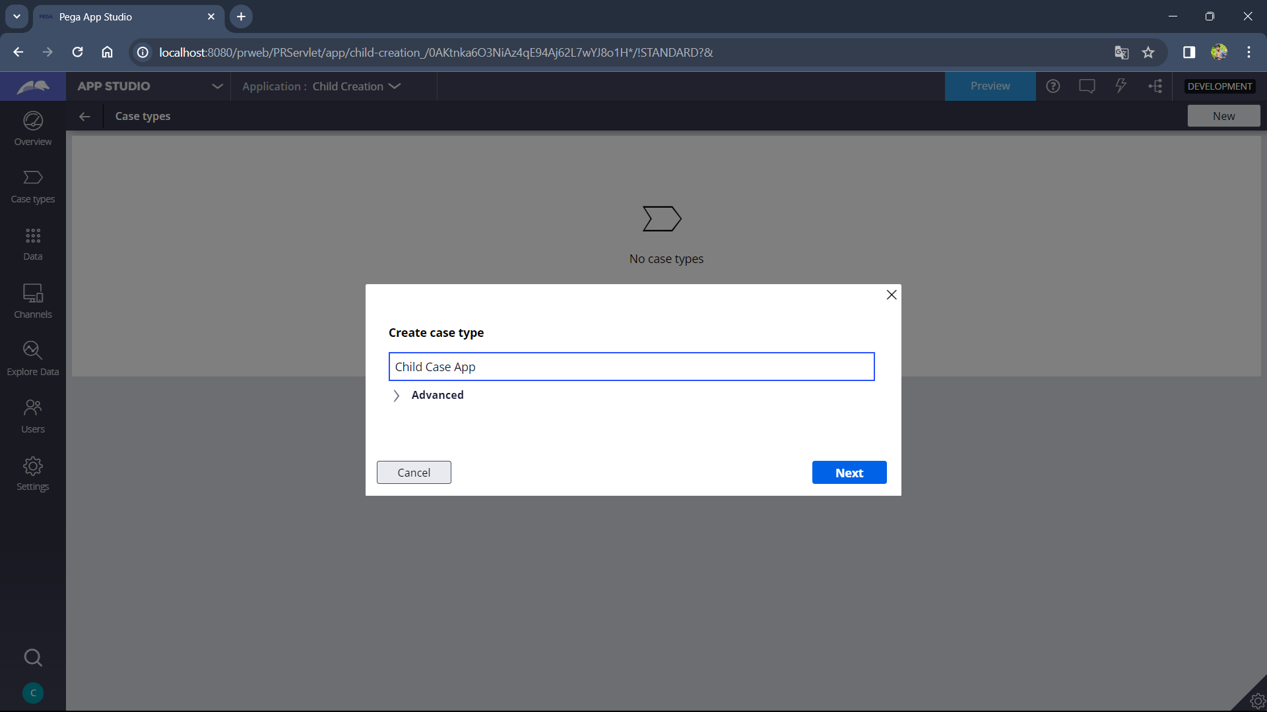

1. Create a stage add a collect info step

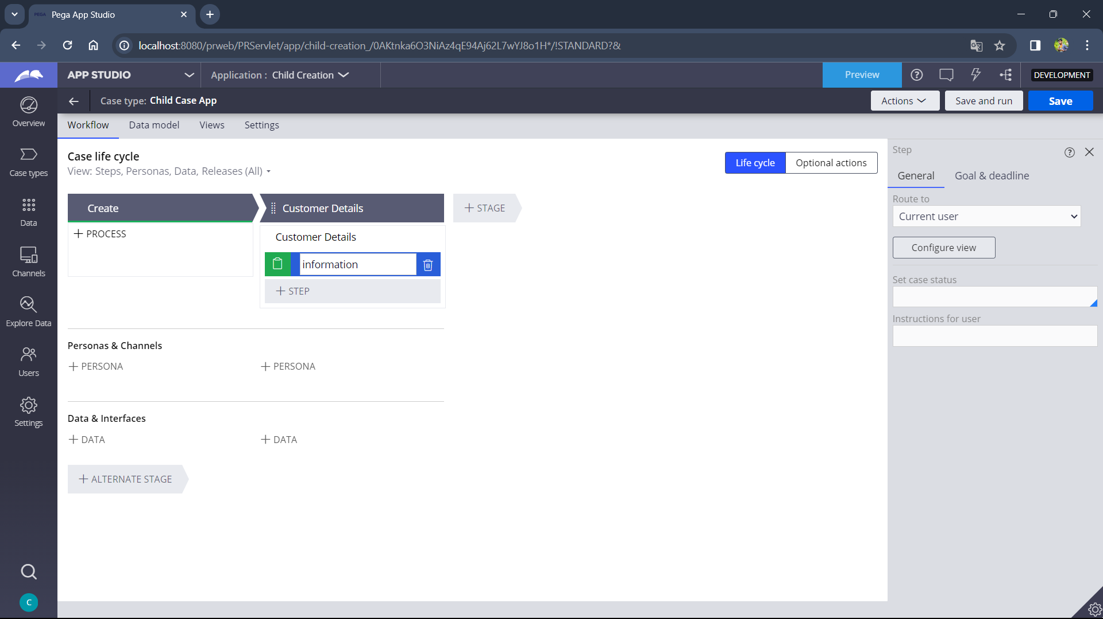

1. Now go to case type and create another case type

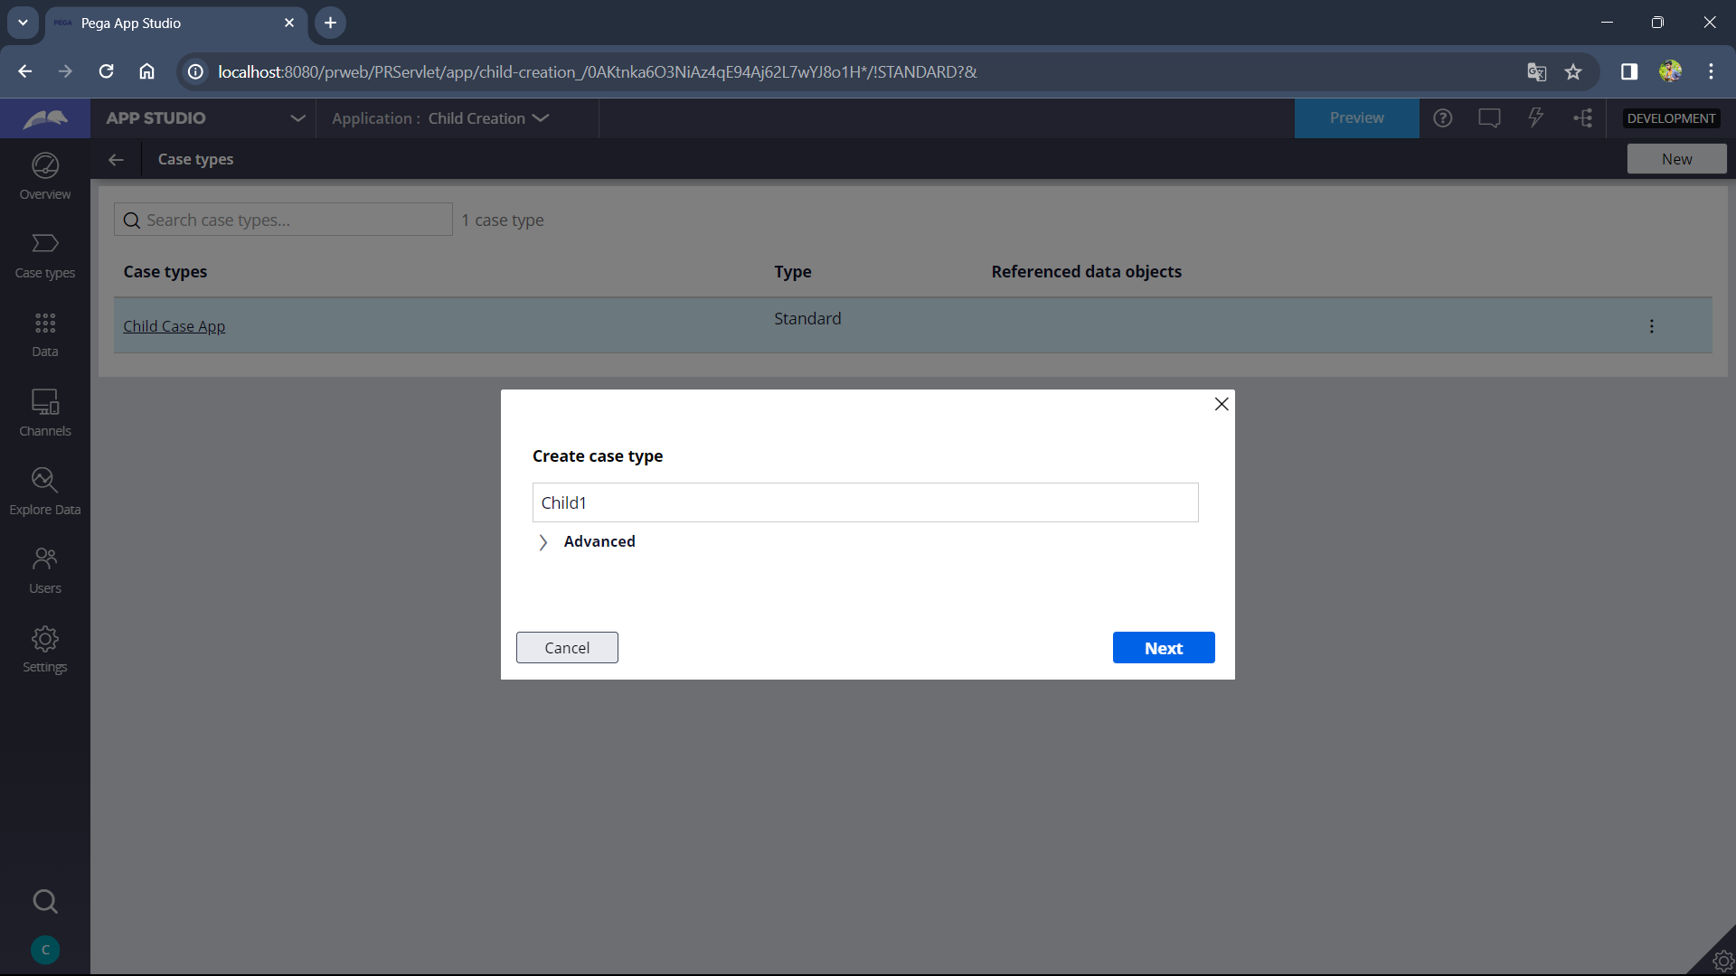

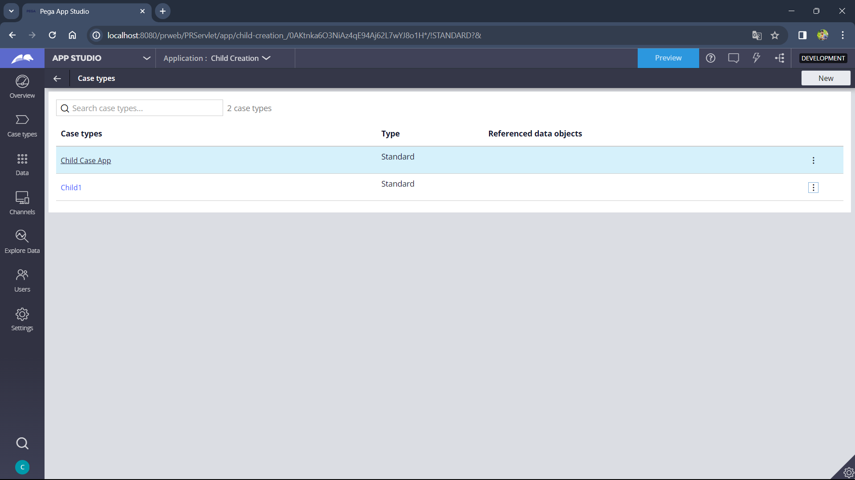

1. Create a stage add a collect info step

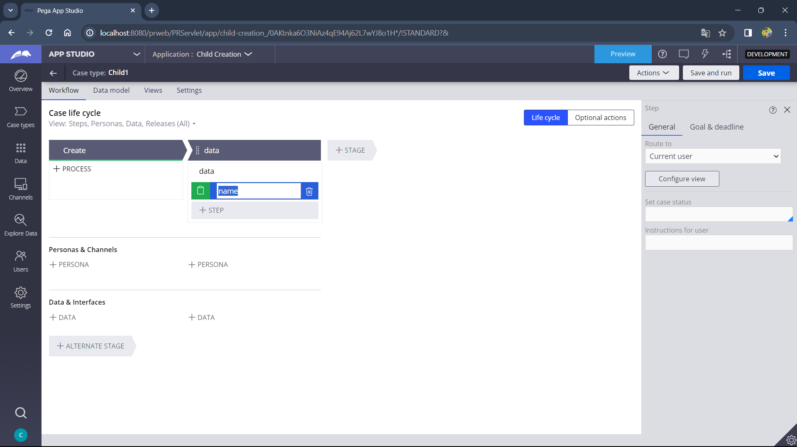

1. Now add a CREATE CASE automation shape and select CHILD1 caste type in select menu.

( Here instead of selecting an already existing case type you can also select create a new case type to create a new child case)

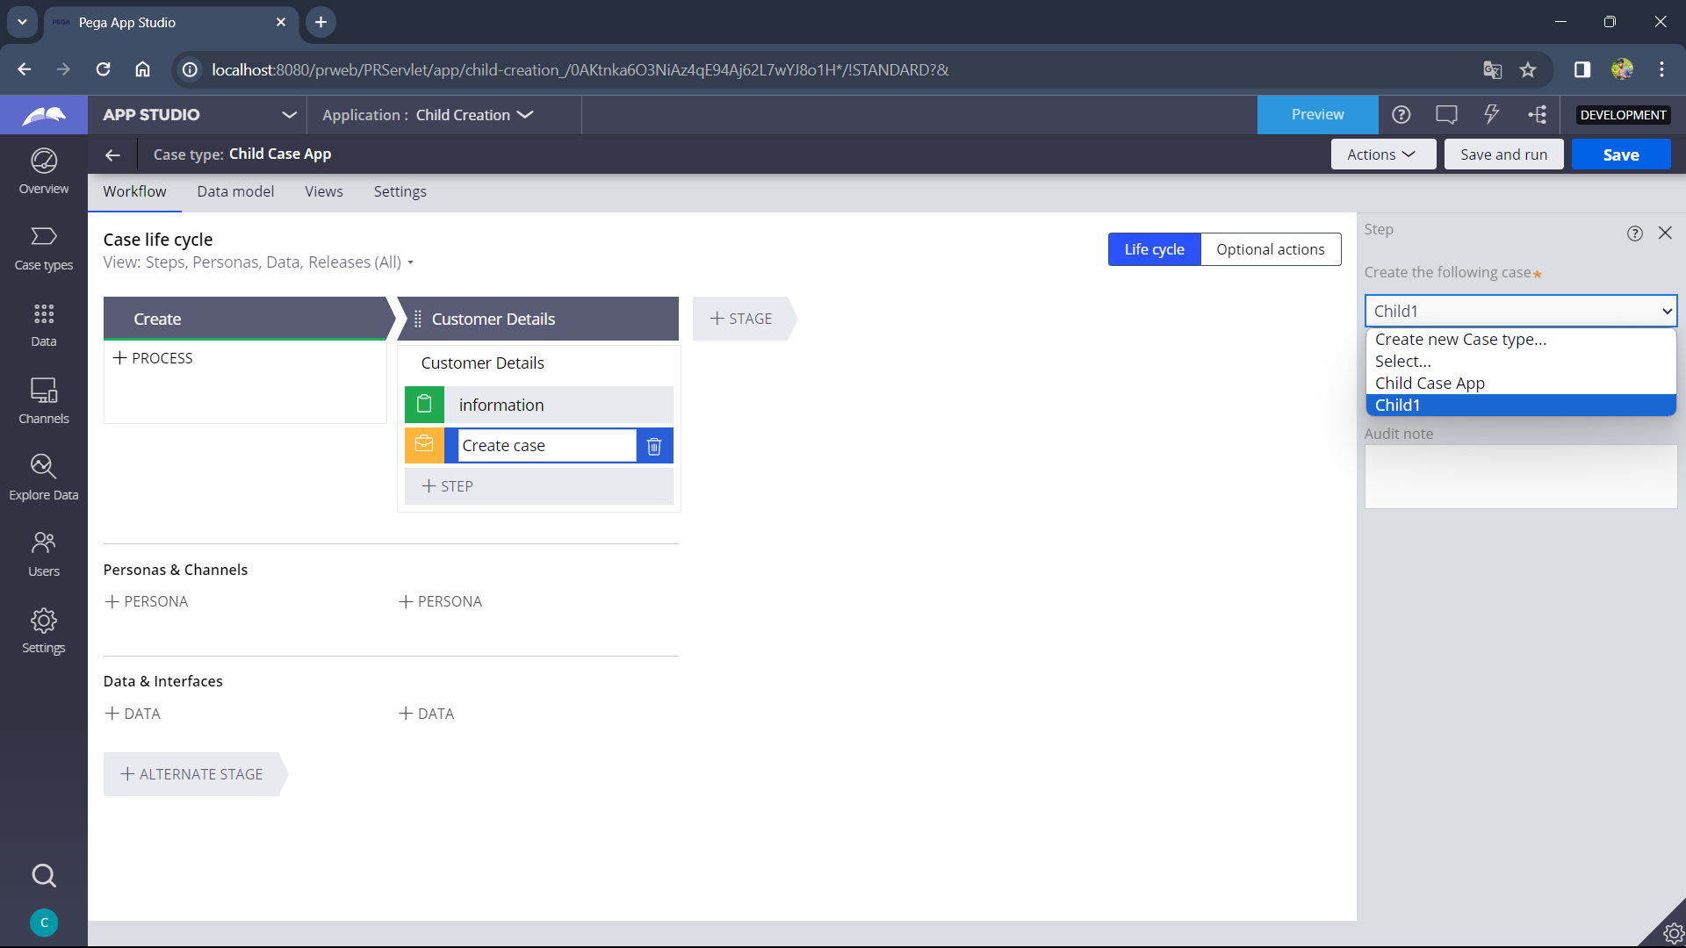

1. Check Transfer Information to new case and select the properties you have to propagate from parent to child case. In to field property of child have to be entered, and click OK and click save.

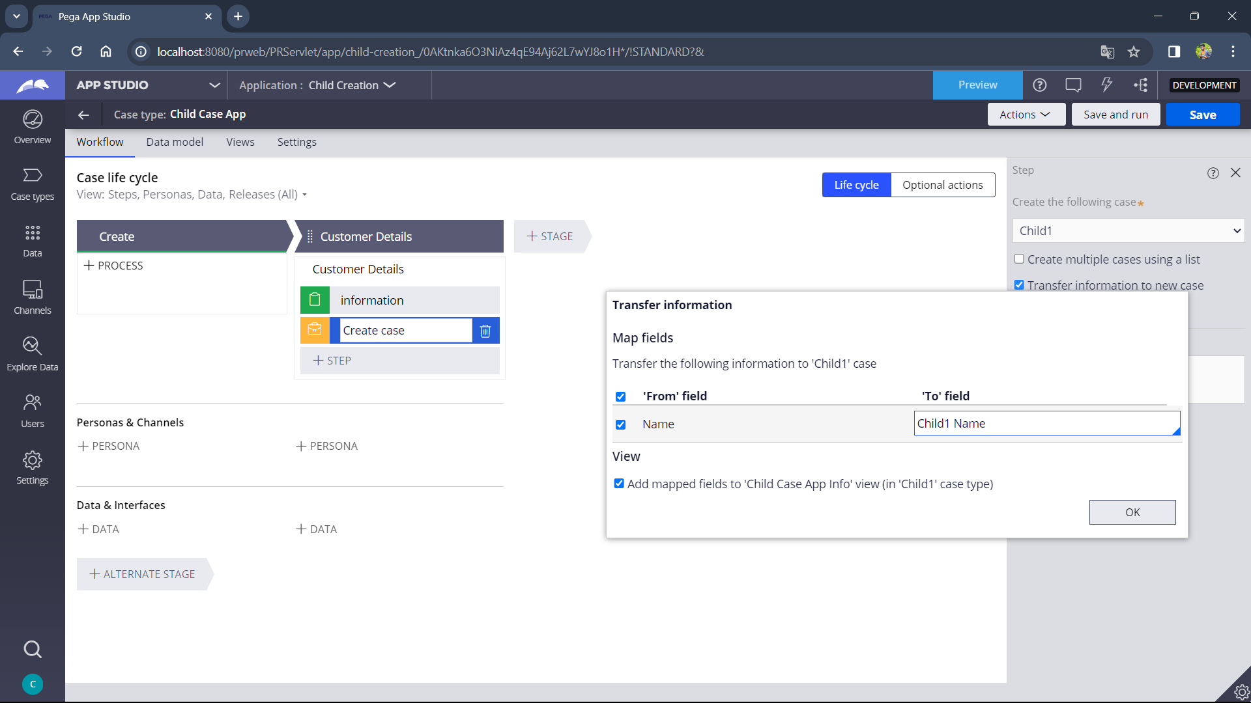

1. Click Save and run and enter the name field and click submit.

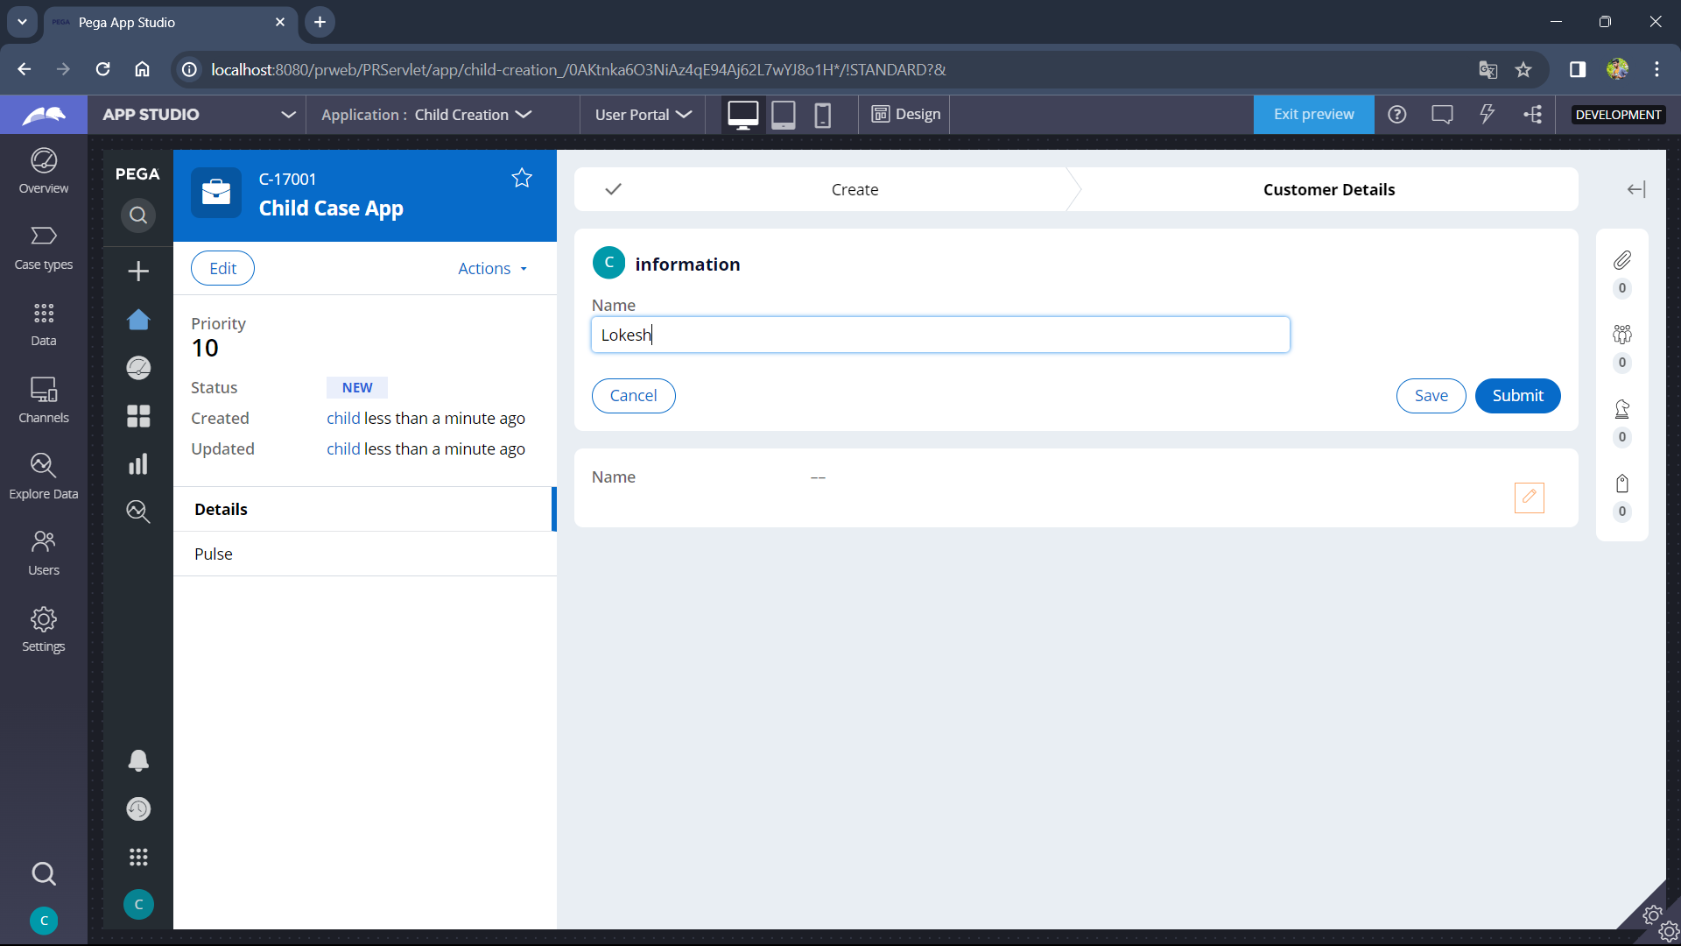

1. After submitting you can see the child case with status to do and we can see the case id

By clicking dropdown of case id C-17001 is parent case Id and C-17002 is child case Id. Click Go

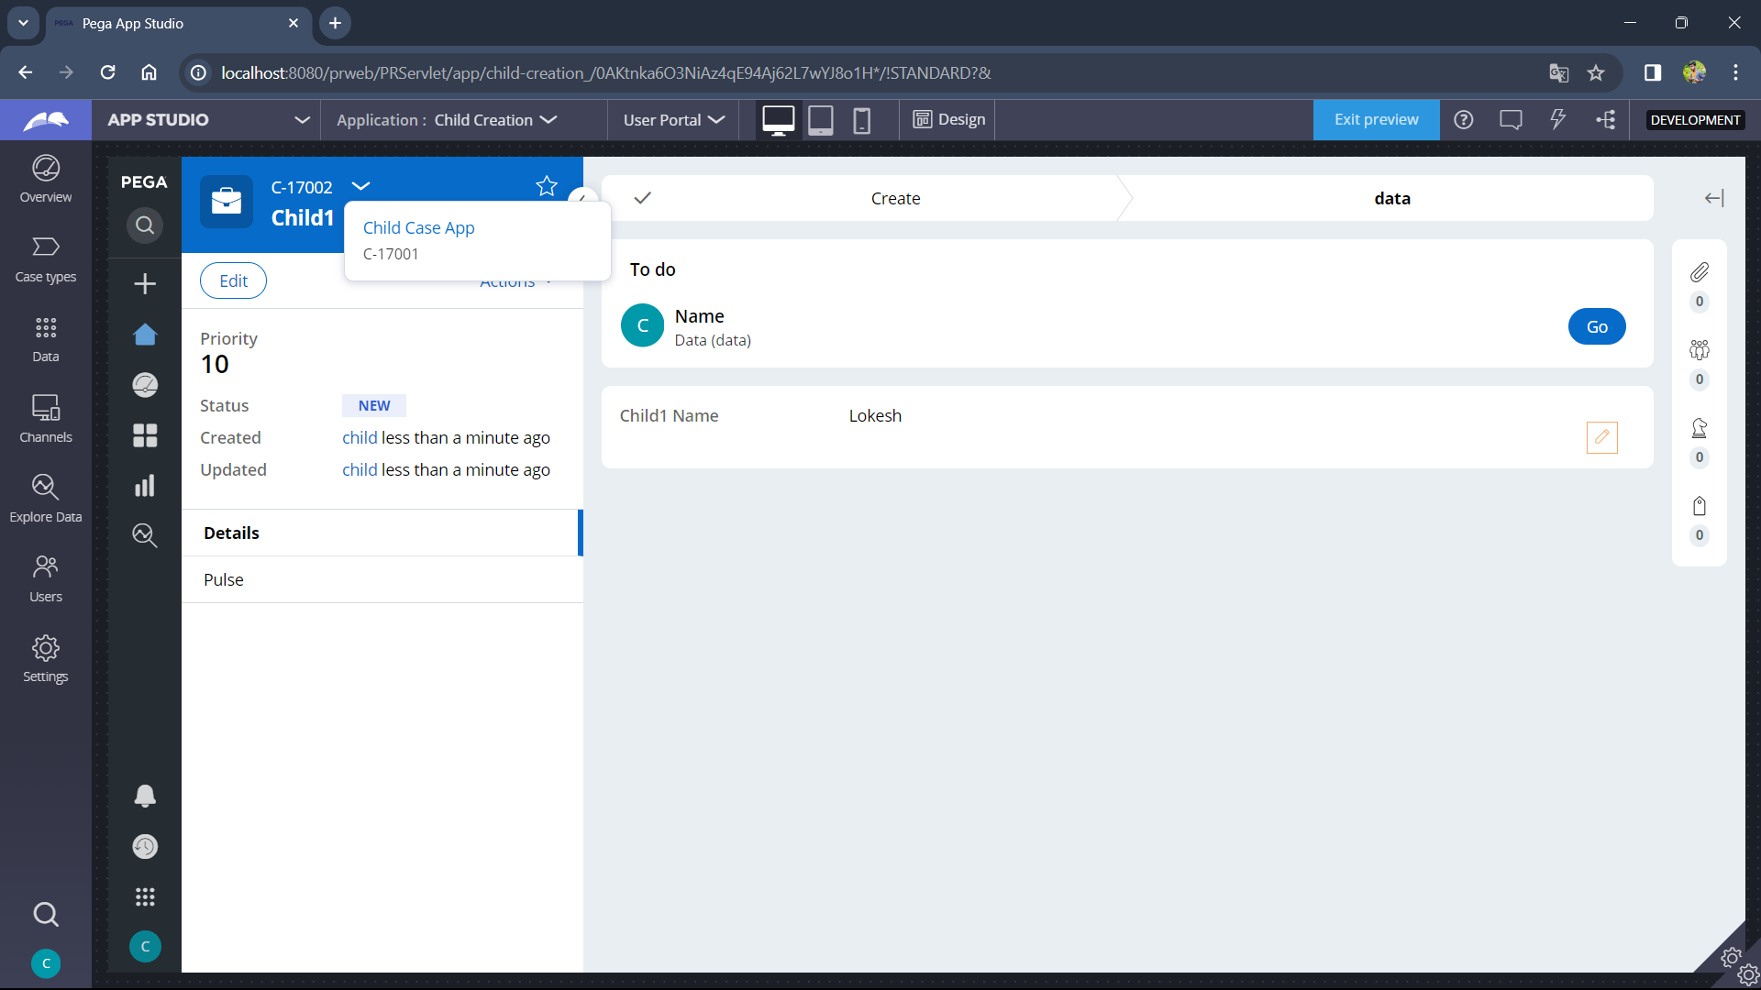

1. Now you can see the child1 name as name given in parent case , i.e, data propagated from Parent case to child case

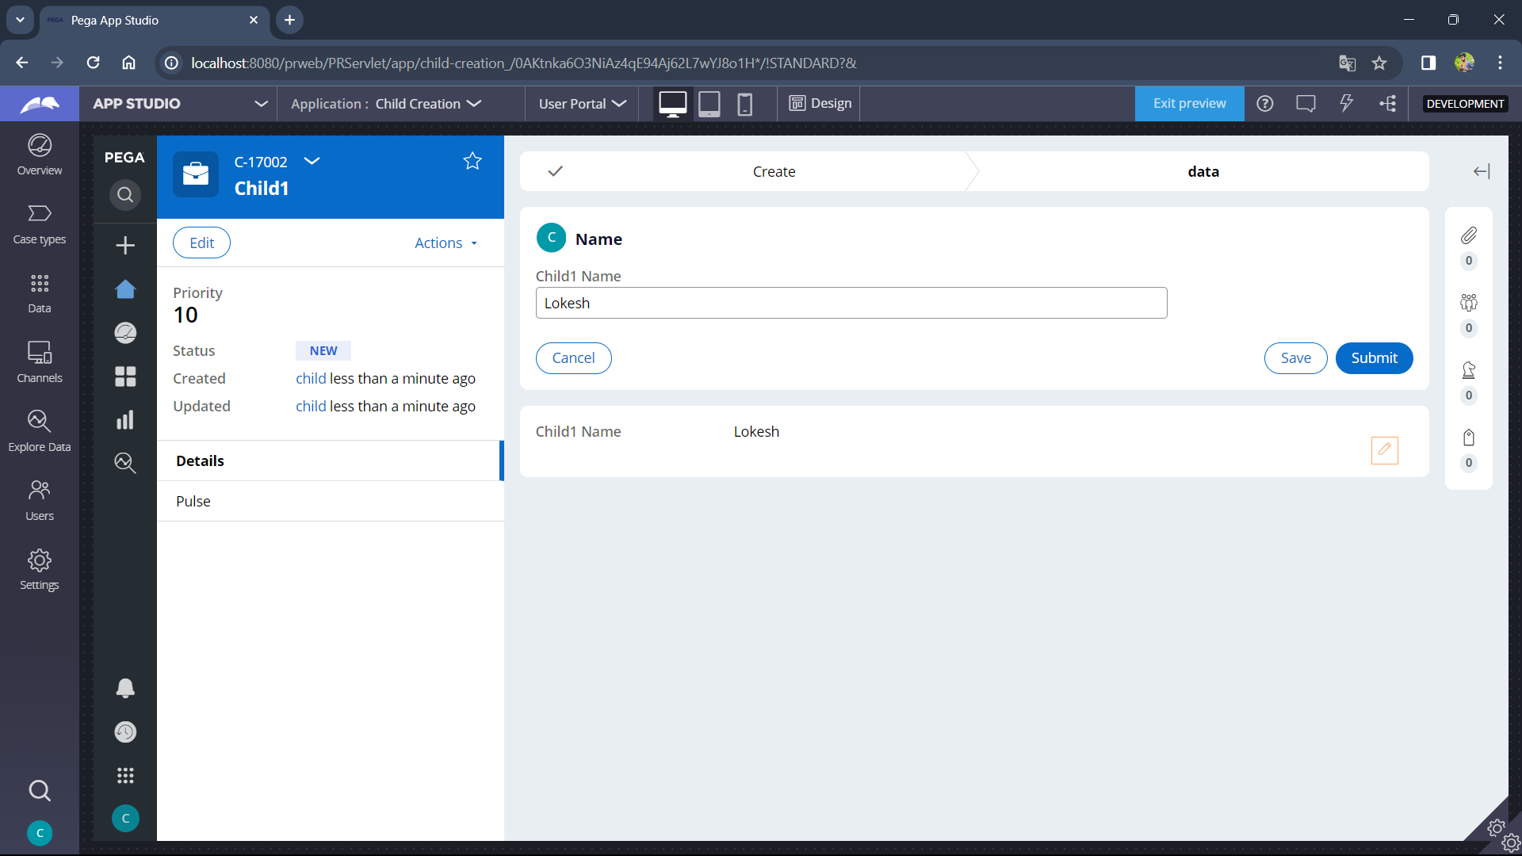

**2. Creating multiple cases using list:-**

1. Create a new case type

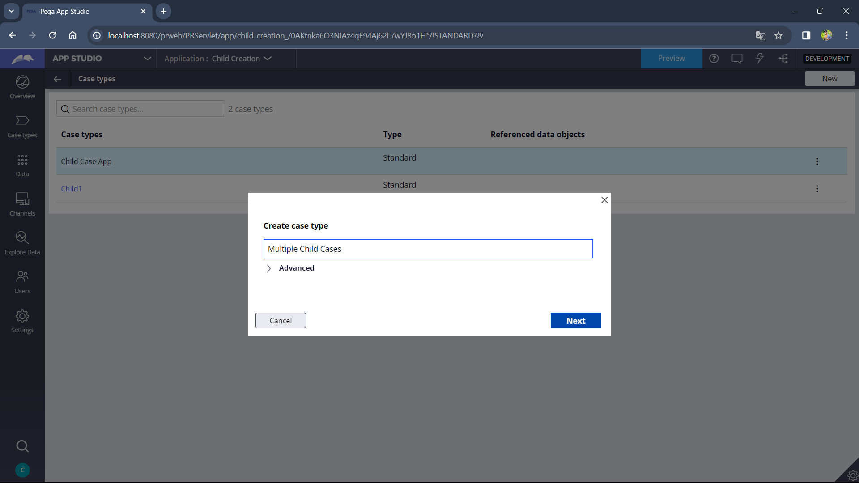

1. Now add an embedded data field , define a new object ,select list of records

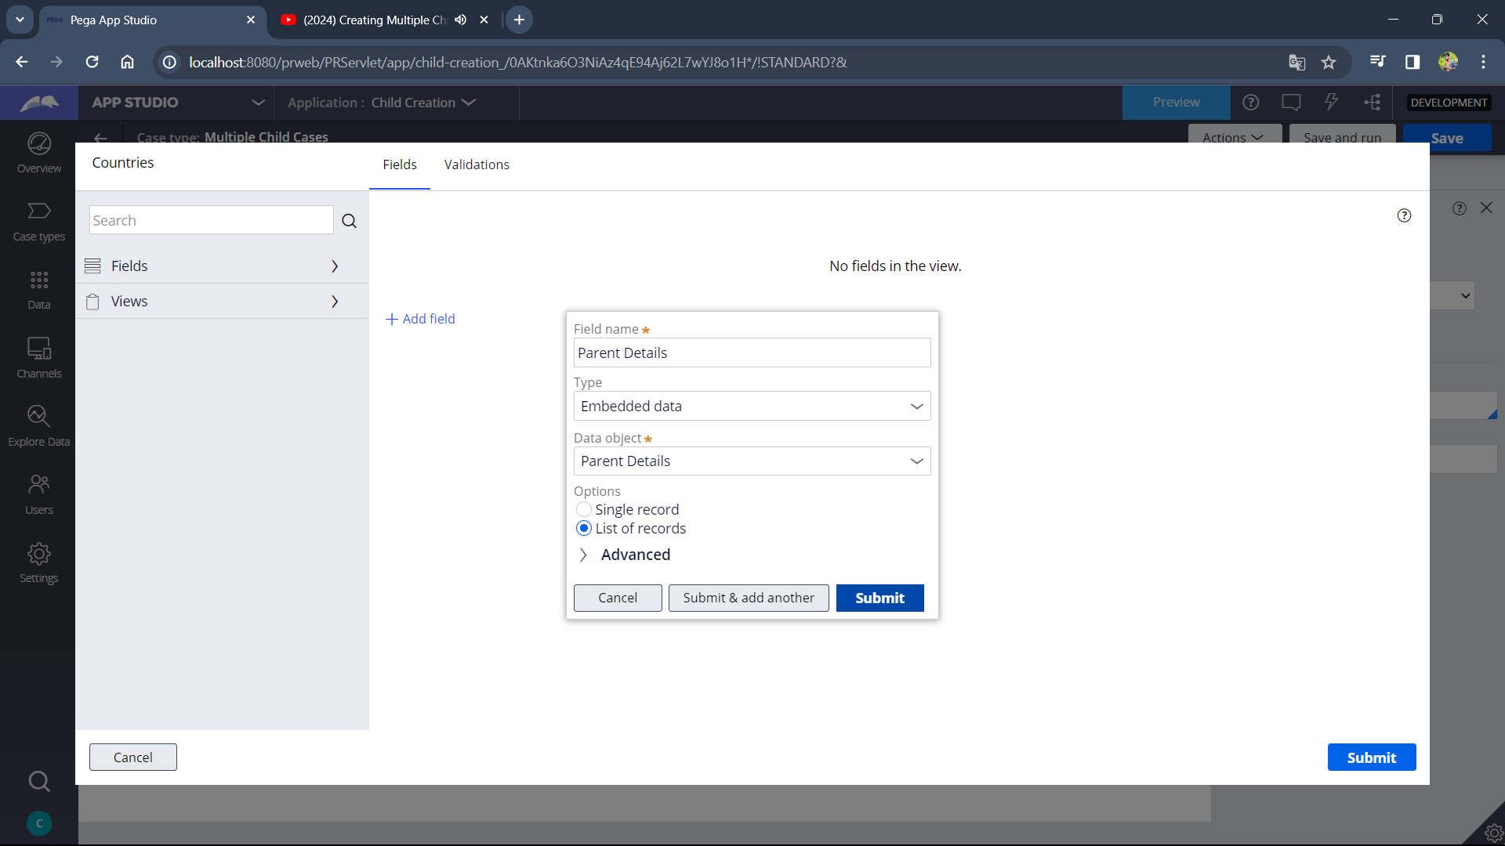

1. Add the required fields , one must be picklist.

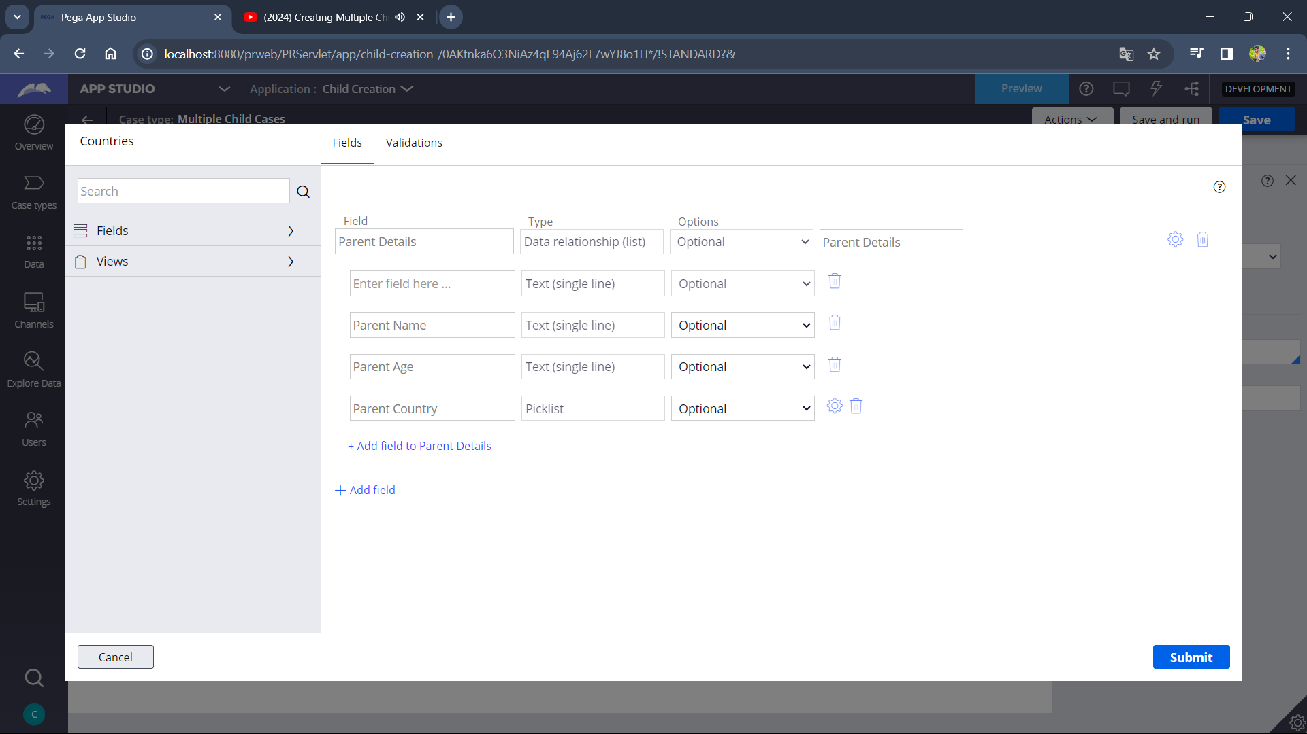

1. Add Create case automation shape and save it and create new case type

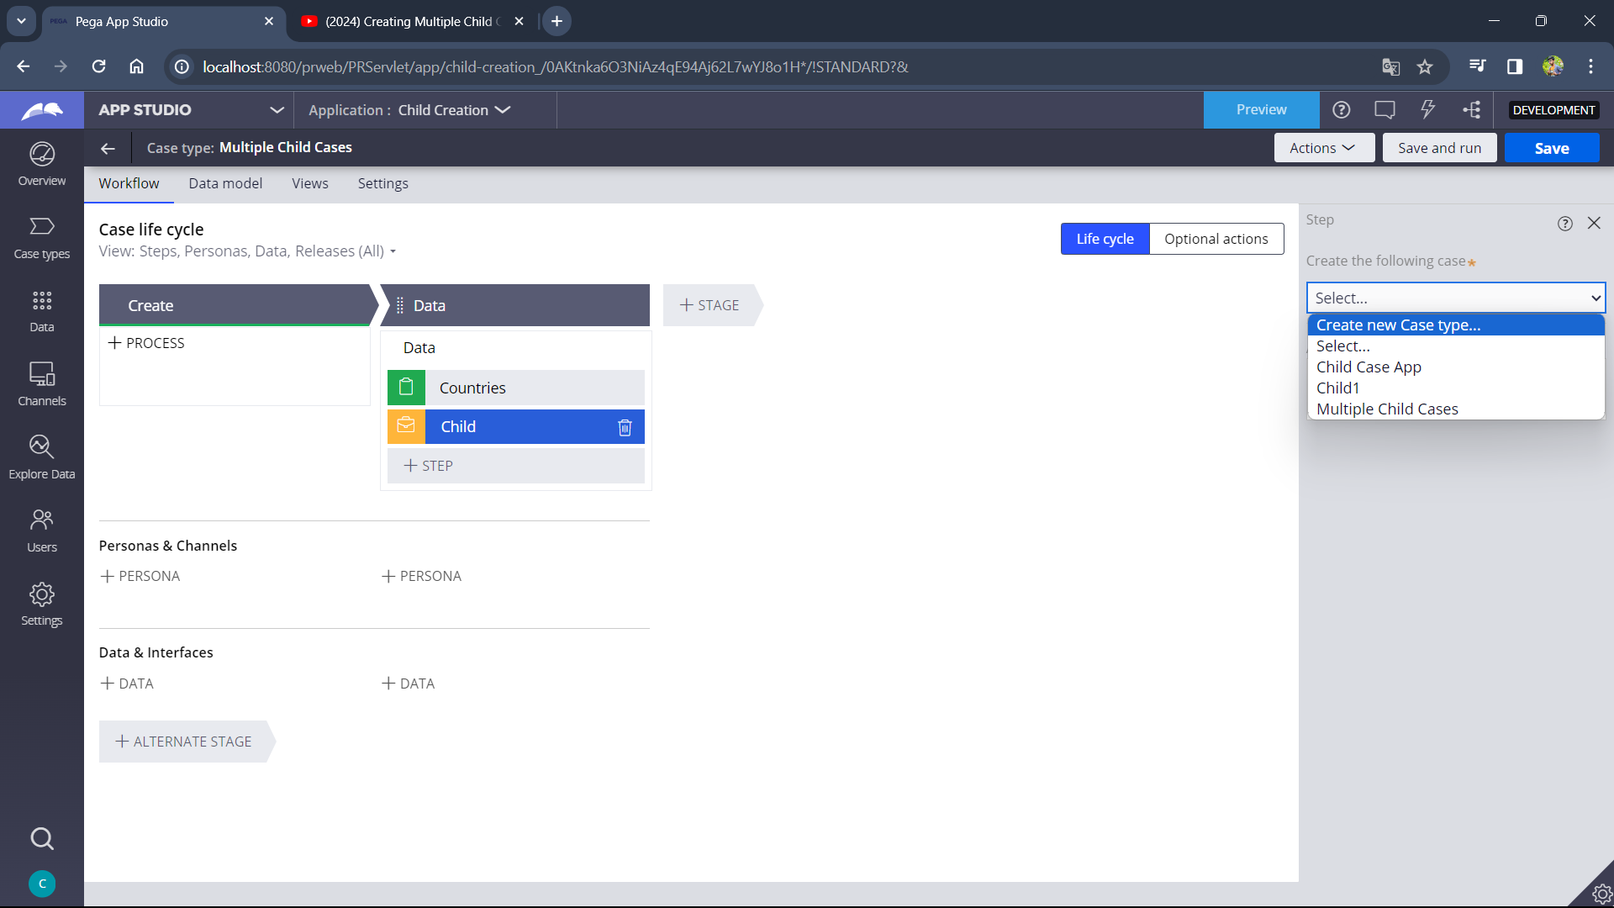

1. Add a stage and collect info step

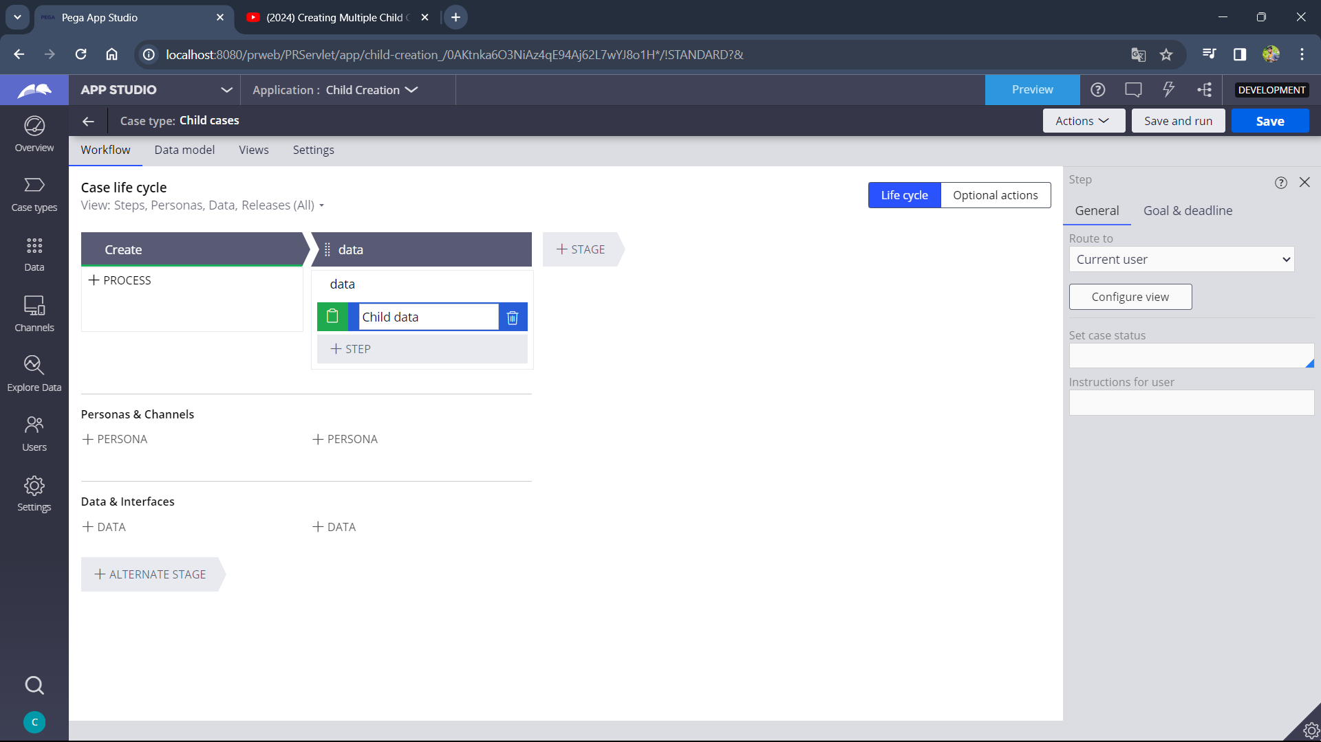

1. Add a embedded data field with parent details as object and select single records, click submit and save.

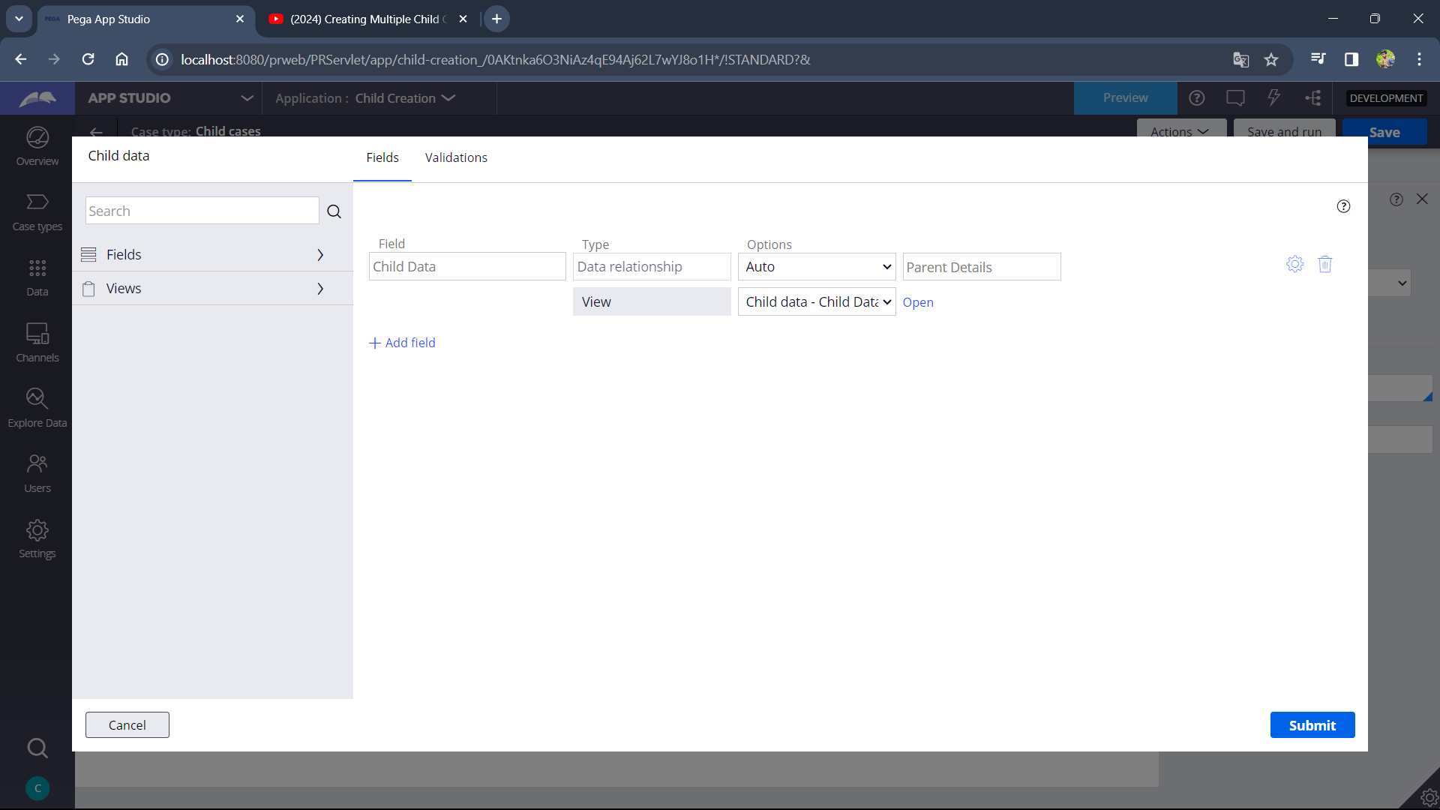

1. Open Parent case and in create case shape select child case you created and check create multiple cases using list and select the list field you created and check transfer information to new case and in the transfer information pop-up in the To Field select the child list field that is created by you in child case type i.e, Child Data and click ok 🡪 submit🡪 save and run.

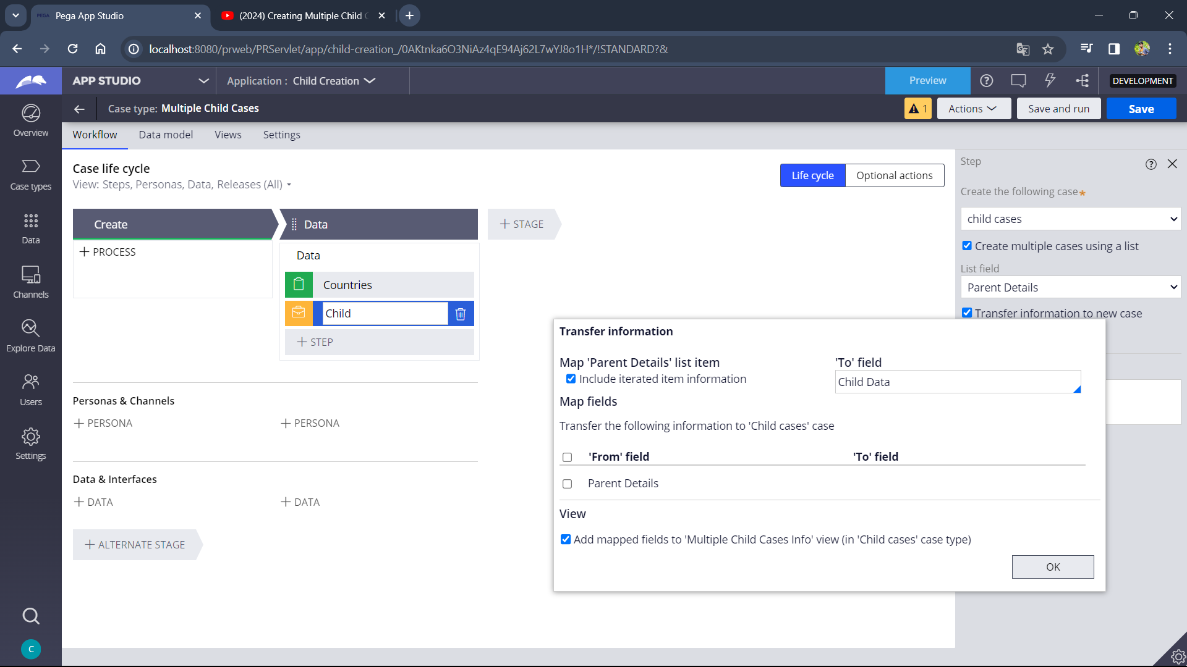

1. Enter details and click submit.

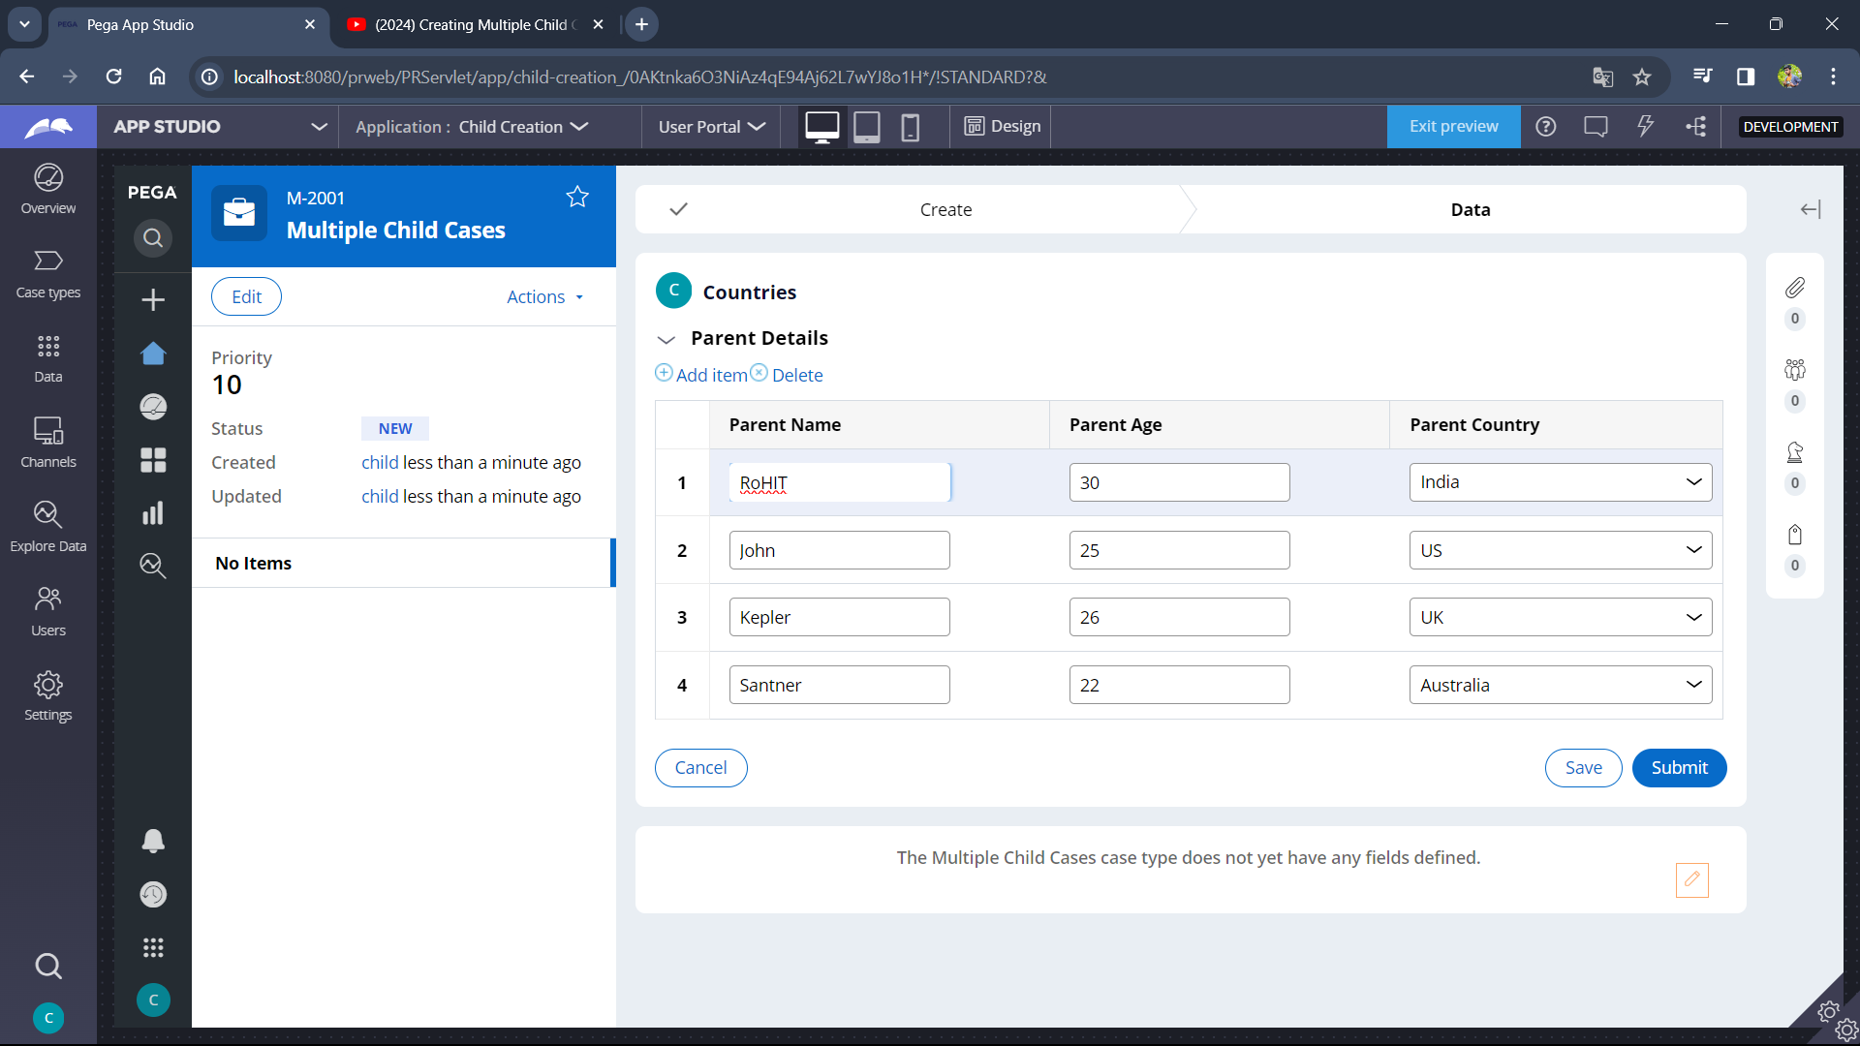

1. Here we can see the child case , click go.

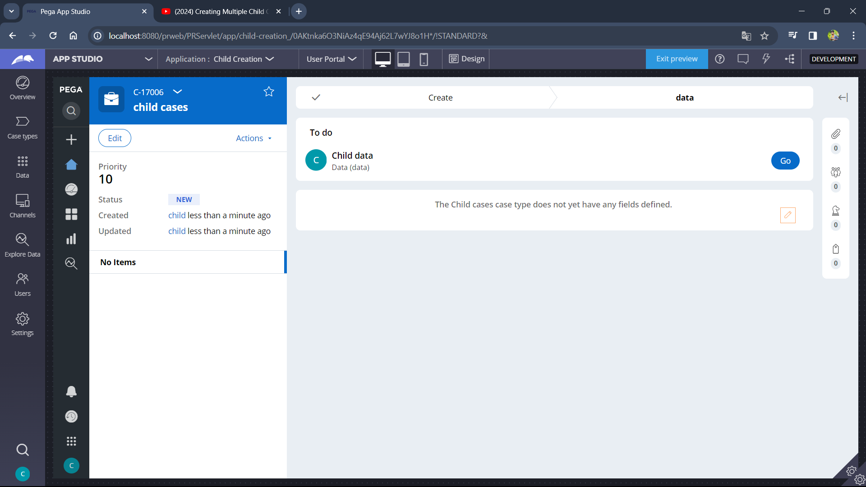

1. It is one of the Child case.

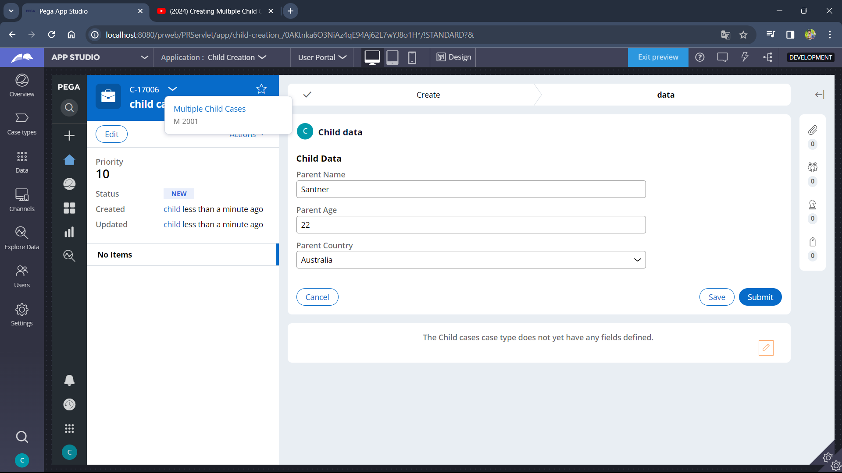

1. Now click on case id dropdown and click on parent case then we can see all remaining child cases.

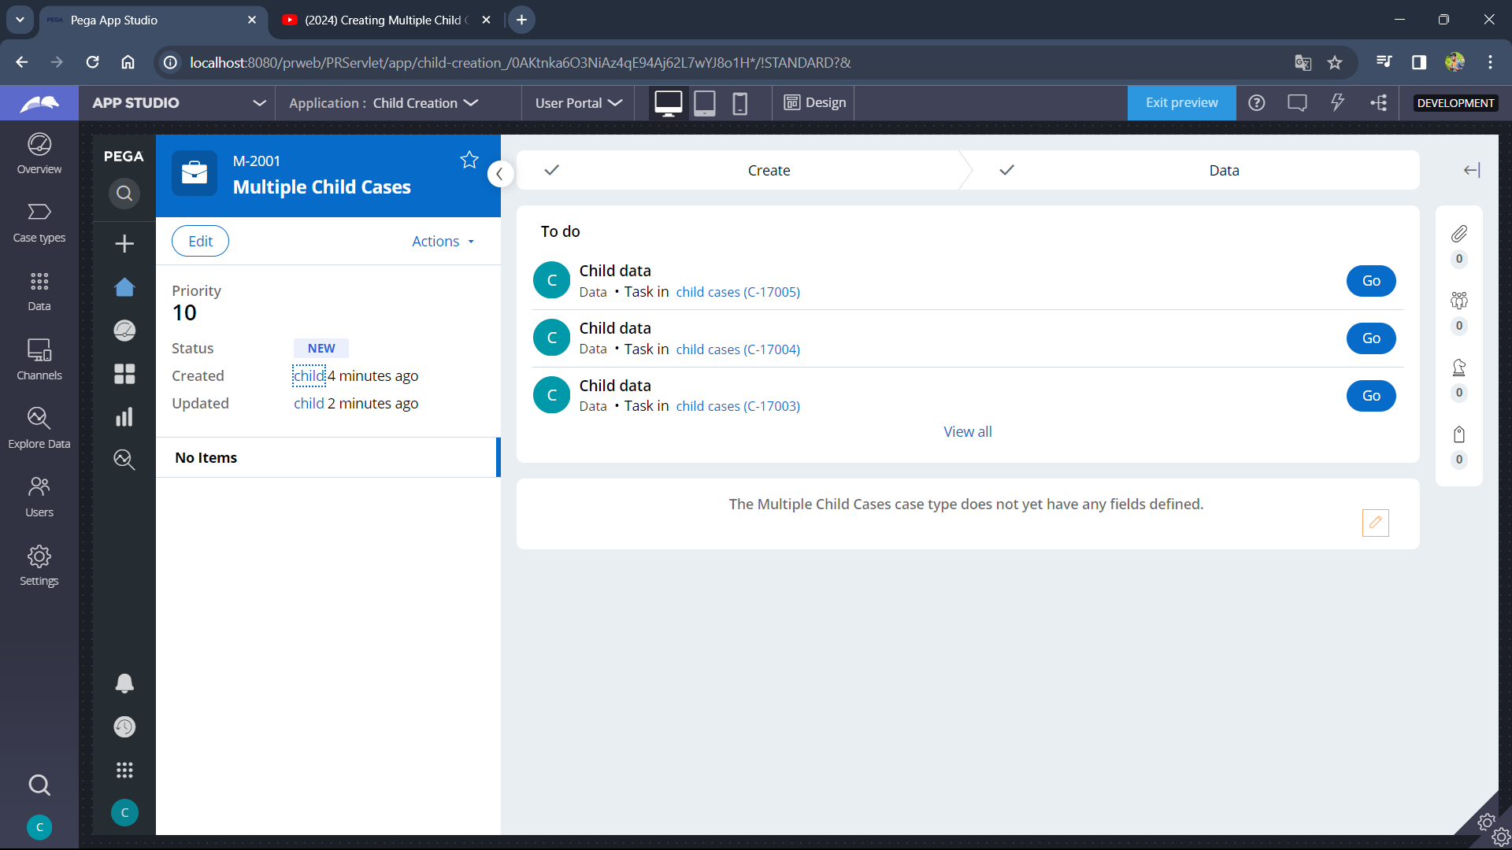

1. Click on Go for required child case.

